AMS588

Practice midterm

Siao Sun

Lulu Deng

Linna Hu

1.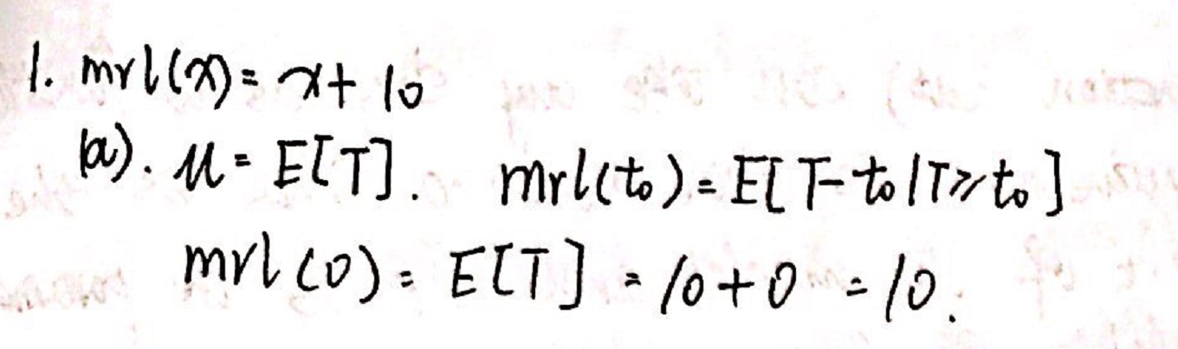

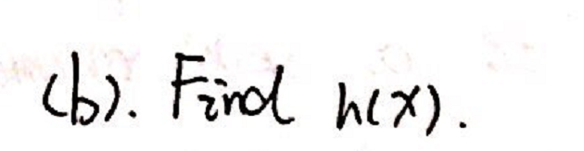

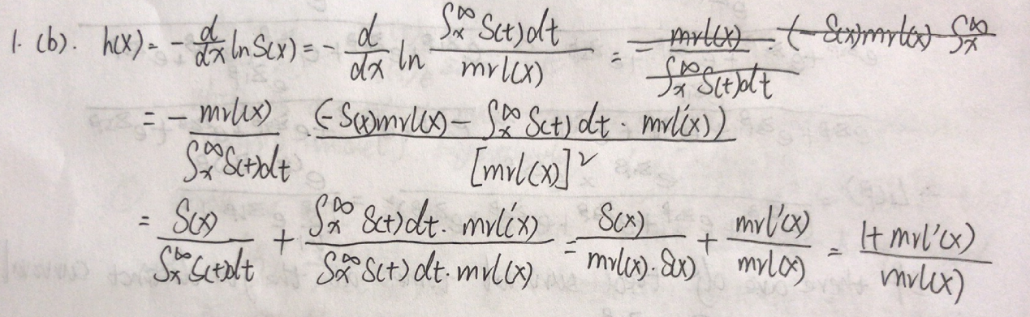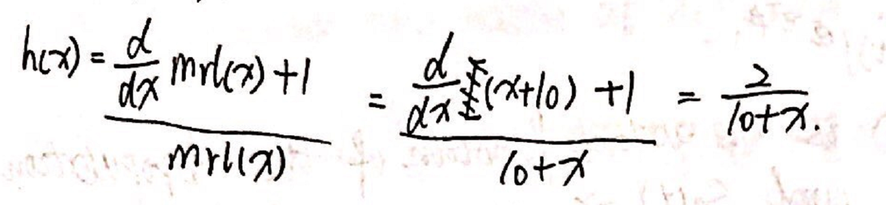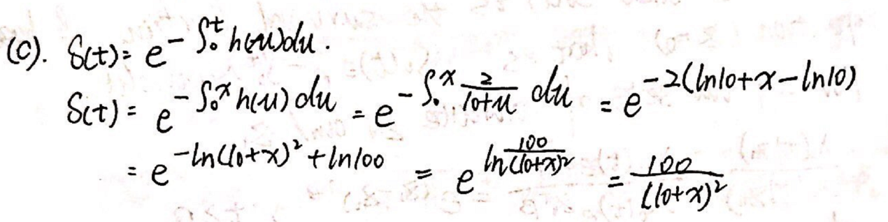

2.

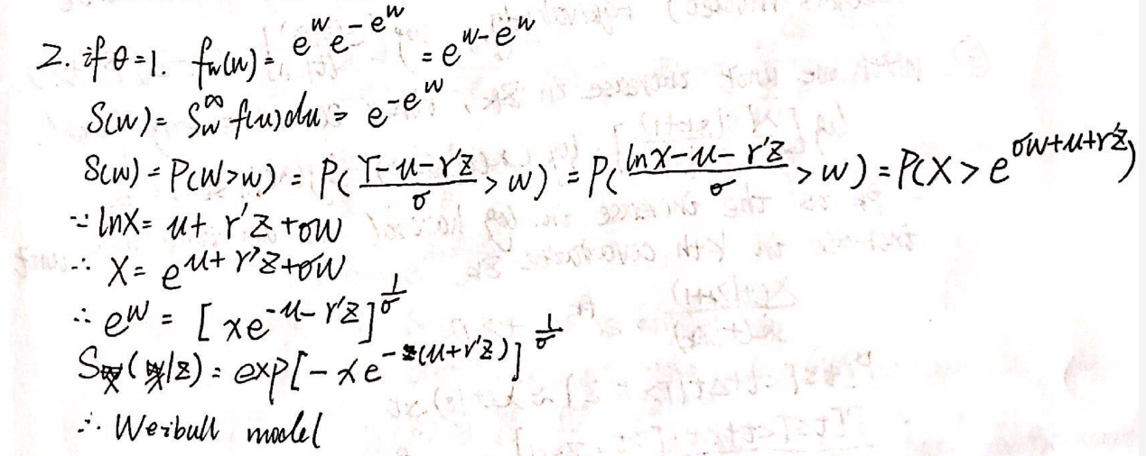

3.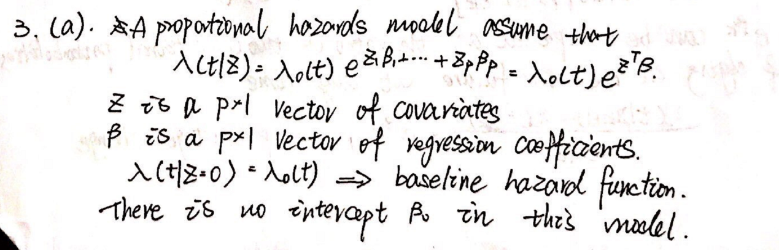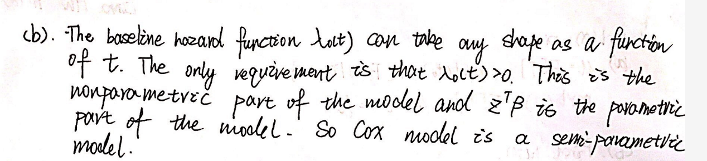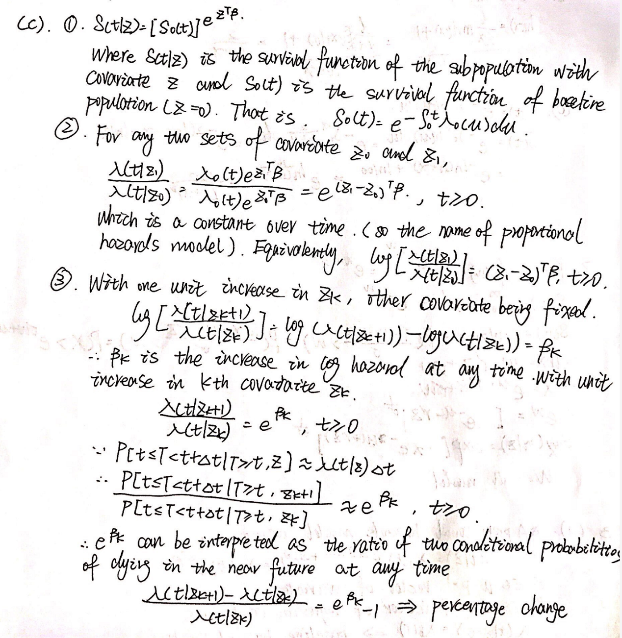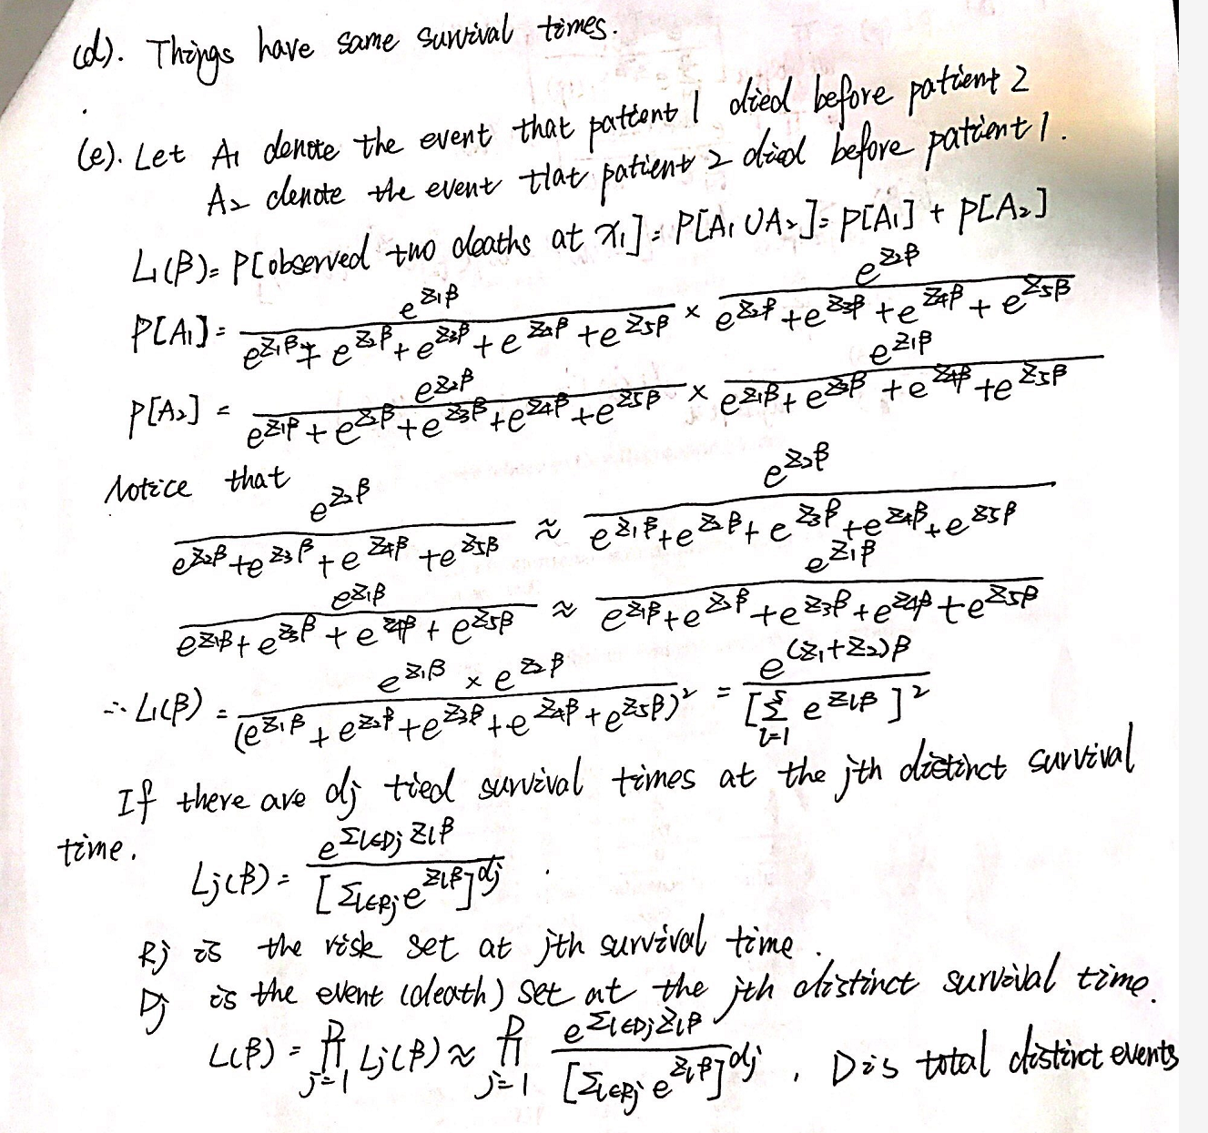

4.

a)

SAS CODE:

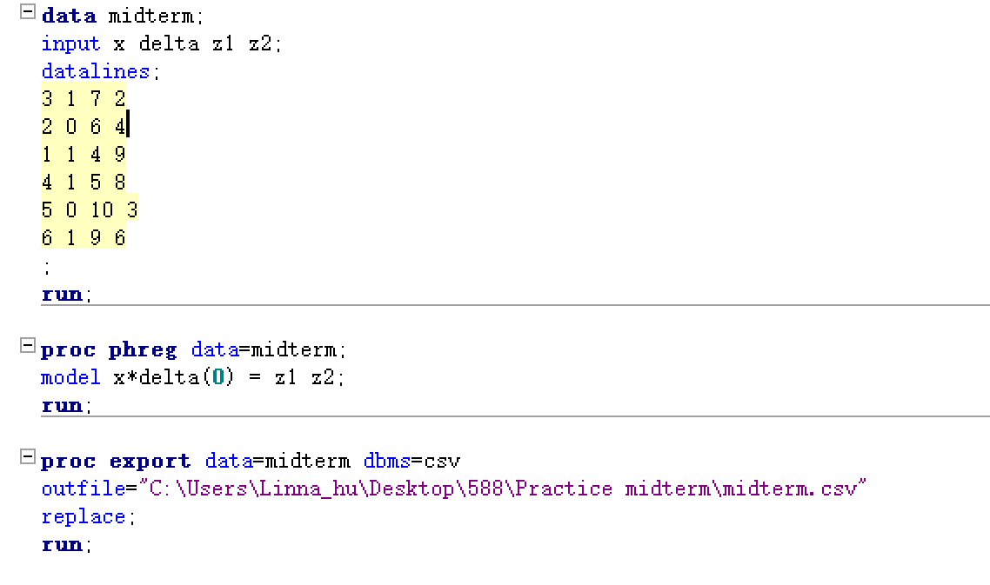

SAS RESULT:

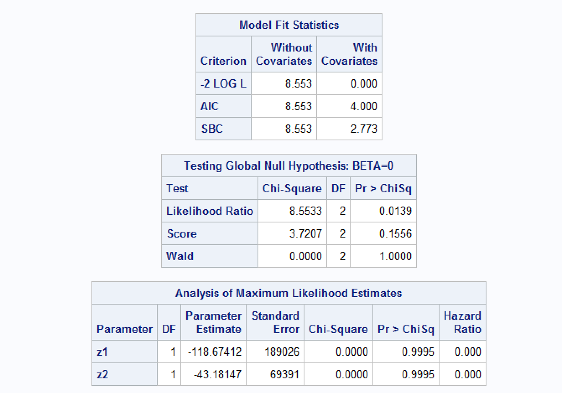

R CODE:



R RESULT:

Call:

coxph(formula = Surv(x, delta) ~ ., data = midterm)

n= 6, number of events= 4

coef exp(coef) se(coef) z Pr(>|z|)

z1 -9.117e+01 2.532e-40 1.552e+04 -0.006 0.995

z2 -3.318e+01 3.885e-15 5.696e+03 -0.006 0.995

exp(coef) exp(-coef) lower .95 upper .95

z1 2.532e-40 3.949e+39 0 Inf

z2 3.885e-15 2.574e+14 0 Inf

Concordance= 1 (se = 0.22 )

Rsquare= 0.76 (max possible= 0.76 )

Likelihood ratio test= 8.55 on 2 df, p=0.01

Wald test = 0 on 2 df, p=1

Score (logrank) test = 3.72 on 2 df, p=0.2

b)

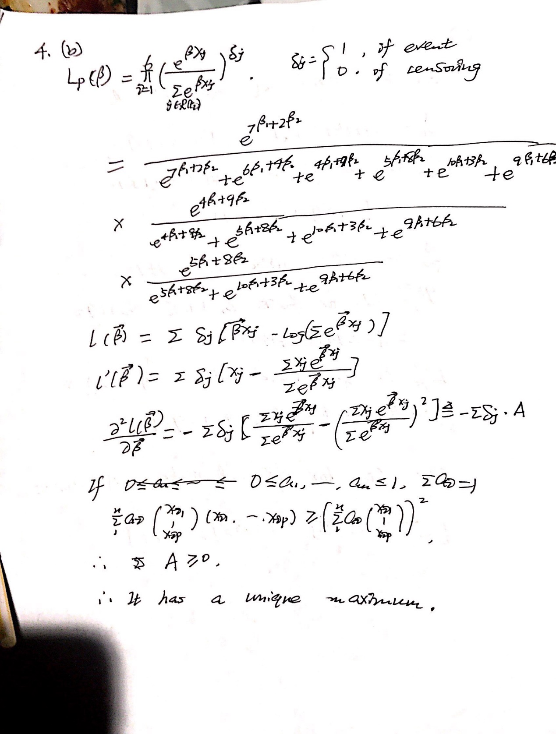

c) 